Merna Ayad
MHA/599 – Capstone: Leading the Organization Through Change
Dr. Kathie Huttegger
Date: April 14, 2021

Introduction
Columbus is one of the most populous cities in the US. In 2019 its population was estimated at 898,553. Despite its large population, the health care system in the city is well organized such that the needs of the whole population are met through the provision of health care services to the residents as well as people outside the city. Columbus has one of the best pediatric hospitals internationally, the best-ranked cancer hospital nationally and it has got two heart hospitals (Oza et al. 2011). The number of other medical centers has also been growing. However, the high population means that there is congestion in the hospitals leading to an increase in the time spent waiting to receive services.
The current state of the health care system in Columbus
Columbus is ranked at number 47 in the value of health as compared to other cities. According to the Dashboard, the residents of Columbus live less healthy lives and spend a lot on health care than those in the other cities. The high health care spending is on the cost of treating health problems. This is because of a lack of effective measures in areas such as childhood misfortunes and trauma that may present long-term impacts, terrible health outcomes, and scarce public health workforce resulting in misused prevention opportunities.
The COVID-19 pandemic has also undermined the effectiveness of health care delivery. Many health care systems in the US have experienced the effects of the pandemic, Columbus being one of the cities affected. The health care system of Columbus city is designed to cater to the needs of its residents. However, people from outside the city have been seeking health care services in this city leading to congestion in the hospitals within the city. This has increased the waiting time since more people are seeking services in the city (Franz et al. 2018). High demand for service means that the health care providers are overworked since they have to attend to more patients. There has also been a challenge of shortage of hospital beds and some of the health equipment.
Proposed service
I would introduce the use of mobile clinics and medical teams to provide screening services for diseases such as cancer and other diseases as well as providing curative services to the vulnerable groups in the city of Columbus. This service will also include responding to childhood adversity and trauma which has not been effectively attended to. This will offer to ensure that the vulnerable and isolated groups get access to the services they need without straining. This service will involve health care providers using vehicles to visit different parts of the city to provide screening services and treat patients who are vulnerable and isolated.
This service will be important in reducing congestions in hospitals. This will in return reduce the number of people visiting hospitals hence reducing the waiting time. This will also help prevent or reduce the transmission of new diseases such as COVID-19. These clinics will serve the vulnerable groups in the community by providing high-quality care at lower costs. There will also be reduced childhood trauma and adversity. The mobile clinics will also improve access to health care services hence promoting the overall well-being of the city.
Designing health facility
The mobile clinic will use semi-trailers for designing the health facility. The length of these trailers ranges from 40’ to 60’, a width of 8’5” to 12’0” and a GVWR of 68,000 pounds. This will provide the greatest interior space-efficient for building the clinic. The semi-trailer will give 1,000 square feet of space. It will be divided into sections such as examination room, reception area and washroom. Proper and adequate ventilation will be maintained in the semi-trailer. The tractor to move the medical trailer will be removable and will only be rented when locating the medical trailer to a different location.
Floor plan
Different types of materials will be used for floor finishing depending on the various sections of the facility. This will ensure that the performance requirements for health care floors are met. For example, LVT, sheet, and linoleum will be used in examination rooms while the other rooms will use LVT, bio-based tile, and sheet tile for floor finishing.
Conclusion
The health care systems in Columbus are faced with various problems including costly health care services which have made the residents have less healthy lives as compared to other cities in the US. The health care system is also faced with congestions in hospitals due to the high demand for services. Implementing the use of mobile clinics in the city may improve access, reduce hospital congestion and enhance the provision of quality and cost-effective services.

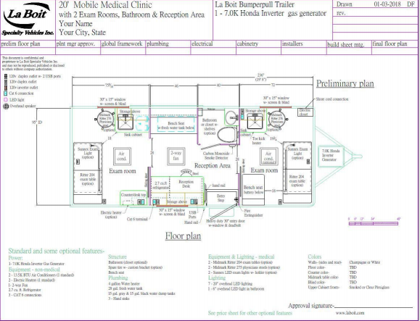

References
Oza-Frank, R., Norton, A., Scarpetti, H., Wapner, A., & Conrey, E. (2011). A report on the body mass index of Ohio’s third graders: 2009-2010. Columbus, OH: Ohio Department of Health.
Franz, B., Skinner, D., Kerr, A. M., Penfold, R., & Kelleher, K. (2018). Hospital–community partnerships: Facilitating communication for population health on Columbus’ South Side. Health communication, 33(12), 1462-1474.
https://www.columbus.gov/publichealth/About/Columbus-Public-Health-History

